UNIVERSITY OF EDUCATION, WINNEBA
FACULTY OF TECHNICAL EDUCATION
DEPARTMENT OF INFORMATION AND COMMUNICATION TECHNOLOGY EDUCATION

DESIGN AND IMPLEMENTATION OF A GHANA SENIOR HIGH SCHOOL LEARNING MANAGEMENT SYSTEM (GSLMS)

A PROJECT REPORT SUBMITTED TO THE DEPARTMENT OF INFORMATION AND COMMUNICATION TECHNOLOGY EDUCATION, UNIVERSITY OF EDUCATION, WINNEBA, IN PARTIAL FULFILMENT OF THE REQUIREMENTS FOR THE AWARD OF THE DEGREE OF BACHELOR OF SCIENCE (BSc) IN ICT EDUCATION

BY
GROUP ONE (1)

2026

DECLARATION
We hereby declare that this project report titled “DESIGN AND IMPLEMENTATION OF A GHANA SENIOR HIGH SCHOOL LEARNING MANAGEMENT SYSTEM (GSLMS)” is our original work and has not been submitted, in whole or in part, to any other institution for the award of a degree or any other academic qualification.
We further declare that all sources of information used in this study have been duly acknowledged and referenced in accordance with the required academic referencing standards. We accept responsibility for the accuracy and originality of the work presented in this project report.

GROUP ONE (1) LEADER
Signature: ............................................................
Date: ...................................................................

GROUP MEMBERS – GROUP ONE (1)
NAME INDEX NUMBER
1 JOHN QUANSAH 5231570032
2 BENEDICT AMANKWA OSEI 5231570098
3 SAMUEL YEBOAH OPOKU 5231570246
4 CHAMME GYAMPO JOSEPH 5231570101
5 FAAKYE RUSSEL 5231570176
6 PENIEL MENSAH-ARTHUR 220020571
7 AMEYAW VINCENT 5231570134
8 ARHIN OBED 5231570239
9 ISAAC ARTHUR 5231570244
10 SULEMANA RAFIATU 5231570361
11 CLEMENT KWESI BAFFOUR 5231570039
2. EXECUTIVE SUMMARY
The Ghana Senior High School Learning Management System (GSLMS) is a web-based platform developed to support teaching, learning, and academic management in Senior High Schools in Ghana. The system provides a centralised platform for administrators, teachers, and students to access and manage learning-related information.
The system uses a PHP-based backend API, a JavaScript frontend, and a MySQL database, with Nginx supporting the web-server environment. The frontend and backend are separated, allowing the system to be easier to maintain, manage, and extend.
GSLMS provides digital management of users, courses, learning materials, and other academic activities. It also incorporates authentication, access control, environment configuration, and logging to support secure and reliable operation.
Overall, the project provides a practical digital solution for improving the management and delivery of learning activities in Ghanaian Senior High Schools.
3. PROJECT OVERVIEW
3.1 Background
The Ghana Senior High School Learning Management System (GSLMS) was developed as a web-based platform to support the management and delivery of teaching and learning activities in Senior High Schools. The project provides a centralised digital environment where users can access academic resources and perform activities according to their roles.
The system was developed as a separate frontend and backend application, with the lms-frontend handling the user interface and the lms-api providing backend services. The project also includes a MySQL database and Nginx web-server infrastructure.
3.2 Purpose
The purpose of GSLMS is to provide a structured digital platform for managing learning activities, reducing reliance on manual processes, and making academic resources and information more accessible to teachers, students, and administrators.
3.3 Objectives
The main objectives of the project are to:
- Provide a centralised platform for managing learning activities.
- Enable users to access the system according to their roles.
- Allow teachers to manage courses and learning materials.
- Provide students with access to relevant learning resources.
- Provide administrators with tools for managing the system.
- Store academic and user information in a structured database.
- Improve the accessibility and organisation of learning resources.
- Provide a maintainable system through separation of the frontend and backend.
3.4 Scope
The scope of the GSLMS covers the development and implementation of the web application, backend API, database, user interface, authentication, learning-resource management, and supporting server configuration. The repository contains dedicated frontend and API components together with database resources and Nginx infrastructure.
The system is intended primarily for Senior High School educational environments, with administrators, teachers, and students interacting with the platform based on their assigned permissions and responsibilities.
4. SYSTEM REQUIREMENTS
4.1 Functional Requirements
GSLMS provides the following major functional requirements:
- User Authentication – Users can log in to the system using their registered credentials.
- User Management – The system supports the management of users and their assigned roles.
- Role-Based Access – Access to system functions is controlled according to the user's role.
- Course Management – Authorised users can create, manage, and access courses.
- Learning Materials – Teachers can upload and manage learning materials for students.
- Student Access – Students can access courses and learning resources available to them.
- Academic Information Management – The system stores and retrieves relevant academic information through the database.
- API Communication – The frontend communicates with the PHP backend through API services.
- Data Management – The system allows authorised users to create, retrieve, update, and manage stored information.
- System Logging – Application activities and errors can be recorded through the available logging mechanisms.
4.2 Non-Functional Requirements
The system was designed to satisfy the following non-functional requirements:
- Security: Authentication and access control should prevent unauthorised access to restricted functionality.
- Performance: The system should process user requests and API operations efficiently.
- Usability: The interface should be simple enough for administrators, teachers, and students to use.
- Reliability: The system should provide consistent access to stored information and learning resources.
- Maintainability: The separation of the frontend and backend makes individual components easier to maintain and modify.
- Scalability: The API-based architecture provides a foundation for adding additional functionality and clients.
- Data Integrity: The database should maintain accurate and consistent user and academic information.
- Compatibility: The web application should operate through modern web browsers.
- Availability: The application should be accessible whenever the required server, database, and network services are running.
The implemented project separates the frontend from the lms-api backend and includes database, environment configuration, and logging components, supporting the maintainability and operational requirements of the system.
5. SYSTEM ARCHITECTURE
The Ghana Senior High School Learning Management System (GSLMS) uses a separated client–server architecture consisting of the frontend application, PHP API backend, MySQL database, and Nginx web server. This structure separates presentation, application logic, and data storage, making the system easier to maintain and extend.
5.1 Architecture Components
Frontend:
The lms-frontend component provides the user interface through which administrators, teachers, and students interact with the system. JavaScript is used to handle user interactions and communicate with the backend API.
API Backend:
The lms-api component contains the PHP backend services responsible for processing requests, applying application logic, authenticating users, and communicating with the database.
Database:
The system uses a relational database to store user accounts, courses, learning materials, and other application data. The repository contains the LMS SQL database used by the application.
Nginx:
Nginx forms part of the server infrastructure and handles web-server/reverse-proxy responsibilities for the application. The repository includes an Nginx installation and associated logs and temporary directories.
5.2 Communication Flow
The general communication flow is:
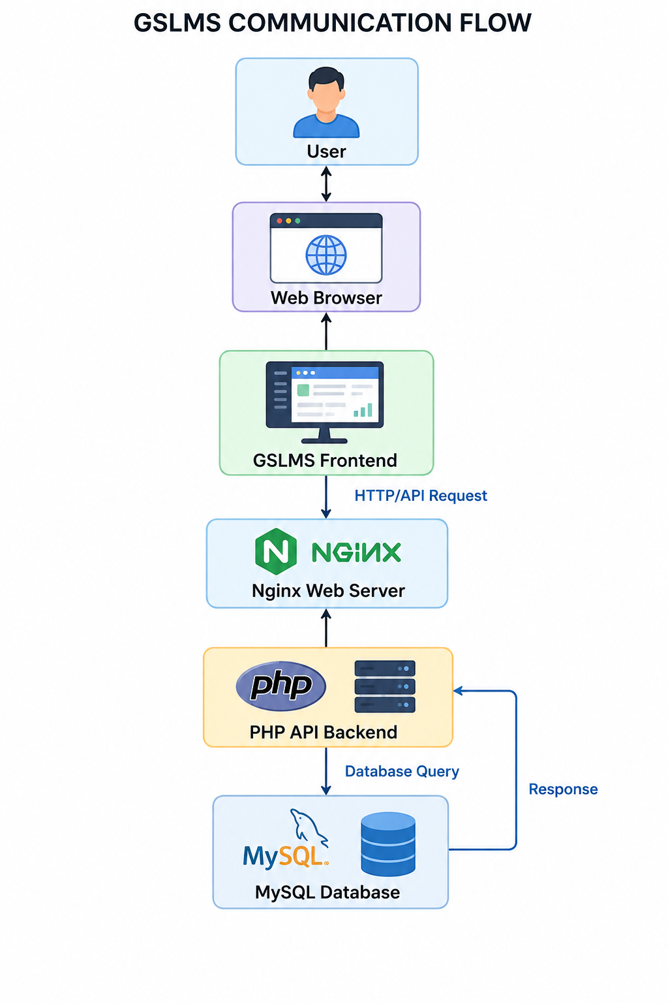
When a user performs an action, the frontend sends a request to the PHP API. The API processes the request and, where necessary, communicates with the MySQL database. The resulting data is returned through the API to the frontend, where it is presented to the user.
The repository reflects this architecture through separate lms-frontend and lms-api directories, together with database resources and Nginx infrastructure.
This architecture provides separation of concerns, allowing changes to the user interface, backend services, or database layer to be made with less impact on the other components. It also provides a foundation for future expansion of the LMS.
6. TECHNOLOGY STACK
The GSLMS was developed using a combination of web development technologies and server-side tools. The major technologies used in the project are:
Technology | Purpose
PHP | Backend/API development and server-side application logic
JavaScript | Frontend functionality, user interaction, and API communication
HTML & CSS | Structure and presentation of the user interface
MySQL | Storage and management of system data
Nginx | Web server and application request handling
Composer | Management of PHP dependencies and backend packages
REST API | Communication between the frontend and backend
JSON | Data format used for API requests and responses
Git & GitHub | Source-code management and project version control
Environment Variables | Management of application configuration and sensitive settings

The project separates the JavaScript-based frontend from the PHP API backend, while MySQL provides persistent data storage. Composer is included within the backend project for managing PHP dependencies. Nginx is also included as part of the server infrastructure.
This technology combination provides the system with a practical foundation for maintainability, modularity, security, and future expansion.
7. SYSTEM MODULES
The GSLMS is organised into several functional modules that provide different services to administrators, teachers, students, and other authorised users. The modules are designed according to user responsibilities and access permissions.
7.1 Administrator Module
The Administrator Module provides system-management functions. Administrators have higher-level privileges for controlling users and managing the overall operation of the platform.
Key functions include:
- Managing system users and their accounts.
- Assigning and managing user roles.
- Managing courses and academic information.
- Monitoring system activities.
- Managing system-level information.
- Controlling access to restricted functions.
- Reviewing system records and logs where applicable.
The administrator therefore serves as the primary user responsible for maintaining the structure and proper operation of the LMS.
7.2 Teacher Module
The Teacher Module provides functionality for teachers to manage their teaching activities and learning resources.
Key functions include:
- Accessing assigned courses.
- Creating and managing course information.
- Uploading and managing learning materials.
- Updating learning resources.
- Making educational content available to students.
- Managing relevant academic activities.
- Accessing information related to students and their courses where authorised.
The module allows teachers to use the system as a digital environment for organising and delivering learning content.
7.3 Student Module
The Student Module is designed to provide students with access to learning resources and academic information.
Key functions include:
- Logging into the LMS.
- Accessing assigned courses.
- Viewing available learning materials.
- Accessing educational resources provided by teachers.
- Viewing relevant academic information.
- Interacting with available learning activities.
The student module focuses primarily on accessing and consuming learning content, while ensuring that students cannot access administrative functions that are outside their permissions.
7.4 Authentication Module
The Authentication Module controls user access to the system. Users are required to authenticate before accessing protected functionality.
The module is responsible for:
- User login.
- Credential verification.
- Authentication status management.
- Access control.
- Protecting restricted API resources.
- Handling authentication-related requests and errors.
Authentication is particularly important because the system contains different user roles with different permissions.
7.5 Course Management Module
The Course Management Module provides functionality for creating, organising, updating, and accessing courses.
The module enables authorised users to:
- Create courses.
- Update course information.
- View available courses.
- Associate learning resources with courses.
- Control access to course information according to user permissions.
This module provides the basic academic structure around which learning content is organised.
7.6 Learning Materials Module
The Learning Materials Module manages the educational resources made available through the platform.
Teachers can use the module to organise learning resources for their courses, while students can access materials made available to them.
The module supports the digital distribution of learning resources and reduces the need to rely entirely on physical copies of educational materials.
7.7 API Module
The API Module forms the communication layer between the frontend and backend. It is implemented within the lms-api component of the project.
The API:
- Receives requests from the frontend.
- Validates incoming information.
- Processes application logic.
- Communicates with the database.
- Returns data to the frontend.
- Provides backend services to authorised users.
The repository contains a dedicated lms-api application separate from the lms-frontend, demonstrating the system's API-based architecture.
7.8 Database Module
The Database Module provides persistent storage for the LMS. It stores information required by the various system modules and allows the backend to retrieve and update information when required.
The project includes an LMS SQL database within the repository, together with a compressed SQL version.
7.9 Logging and Monitoring
The system also contains logging components for recording application activities and errors. Logs are available for areas such as authentication, access, debugging, auditing, email operations, and general errors.
These logs are useful for:
- Troubleshooting application problems.
- Investigating failed requests.
- Monitoring authentication activity.
- Identifying system errors.
- Supporting system maintenance.
7.10 Module Interaction
The major modules work together through the API:
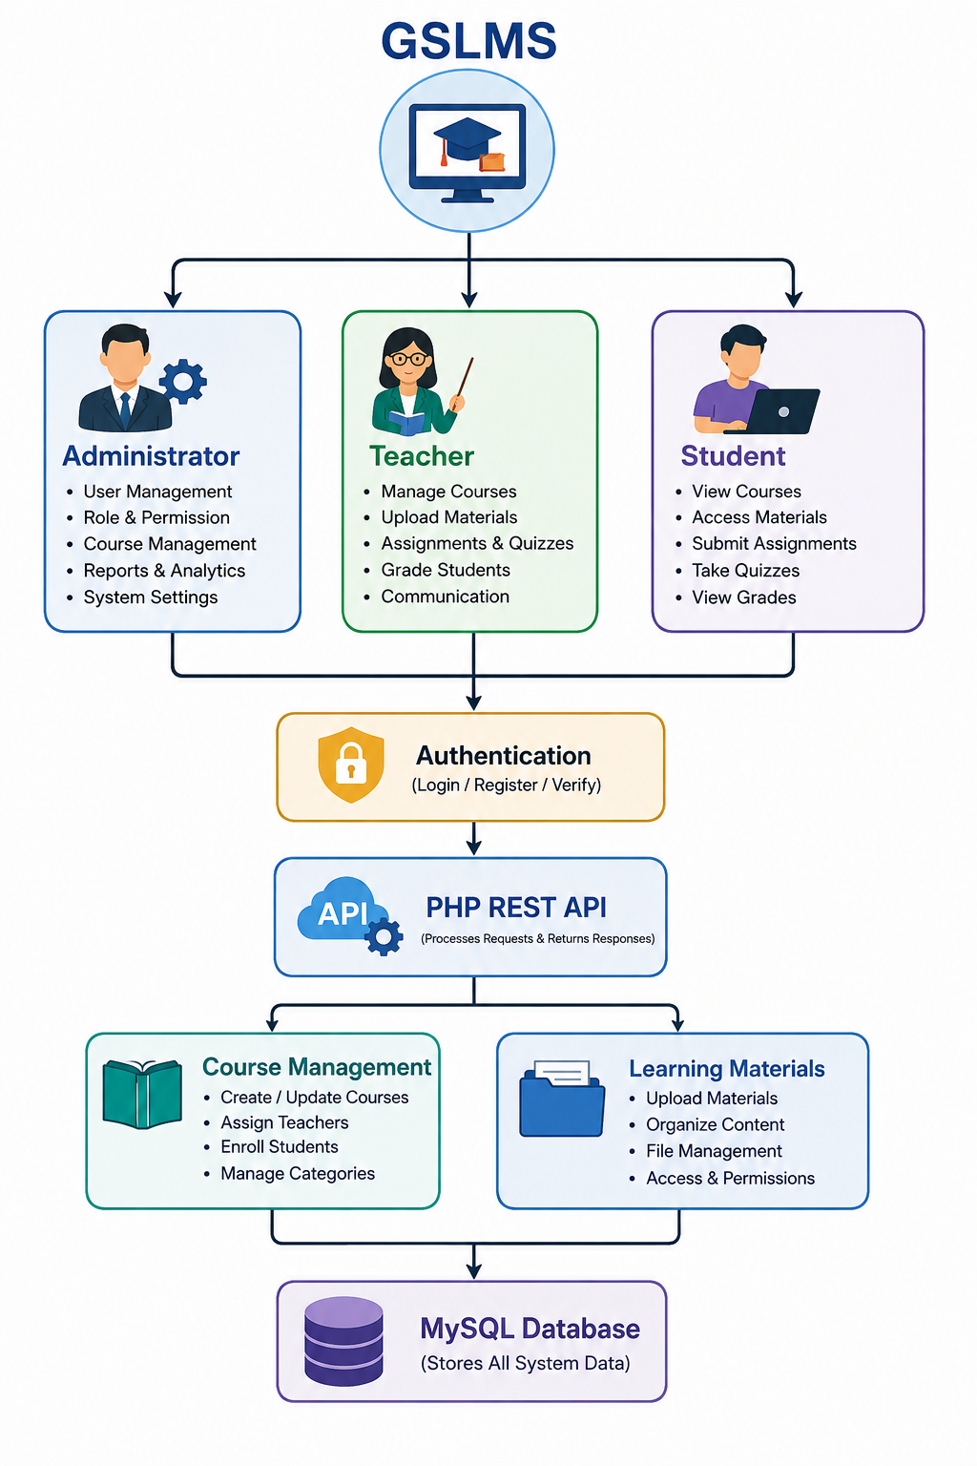
This modular structure allows each area of the system to perform a specific responsibility while communicating with the other components through the backend API. It also makes the system easier to maintain and provides a foundation for adding additional modules in future versions.
8. DATABASE DESIGN
The GSLMS uses a relational database to store and manage the information required by the system. The database provides persistent storage for user accounts, courses, learning resources, and other academic information. The project includes an SQL database file containing the implemented LMS database structure.
8.1 Database Structure
The database is designed around related entities rather than storing all information in a single table. This approach reduces data duplication and allows information to be efficiently retrieved and maintained.
The major data areas include:
- Users – stores information about registered system users.
- Roles – identifies the type and permissions associated with users.
- Courses – stores information about courses available within the LMS.
- Learning Materials – stores information about educational resources associated with courses.
- Student/Course Relationships – manages the association between students and courses.
- Academic Records – stores relevant academic information generated through system activities.
8.2 Relationships
The major relationships can be represented conceptually as follows:
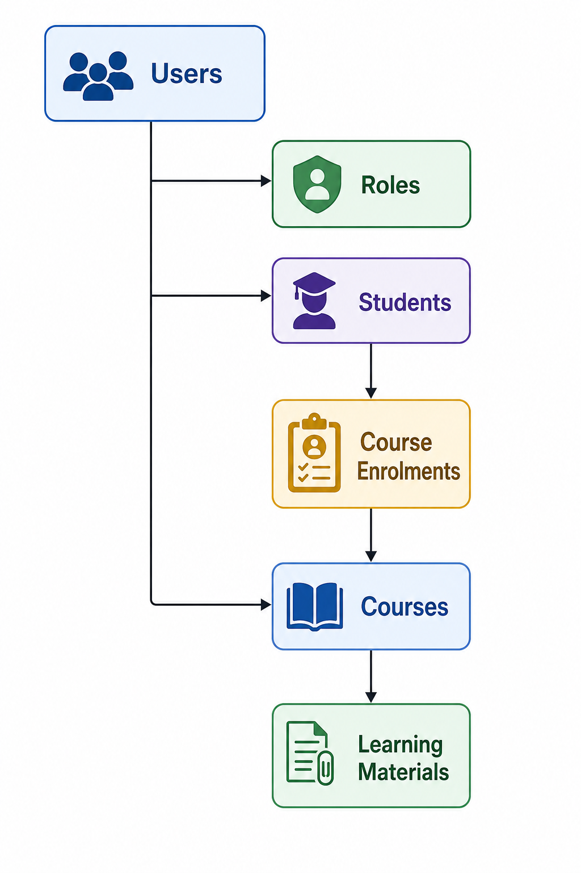
A user is associated with a particular role, which determines the functions that the user can access. Teachers can be associated with courses, while students can be associated with courses through enrolment or related academic records.
A course can have multiple learning materials, allowing teachers to provide different resources for a particular subject or course. Students can then access the resources associated with courses available to them.
8.3 Database Interaction
The database is accessed through the PHP API rather than directly by the frontend. The communication process is:
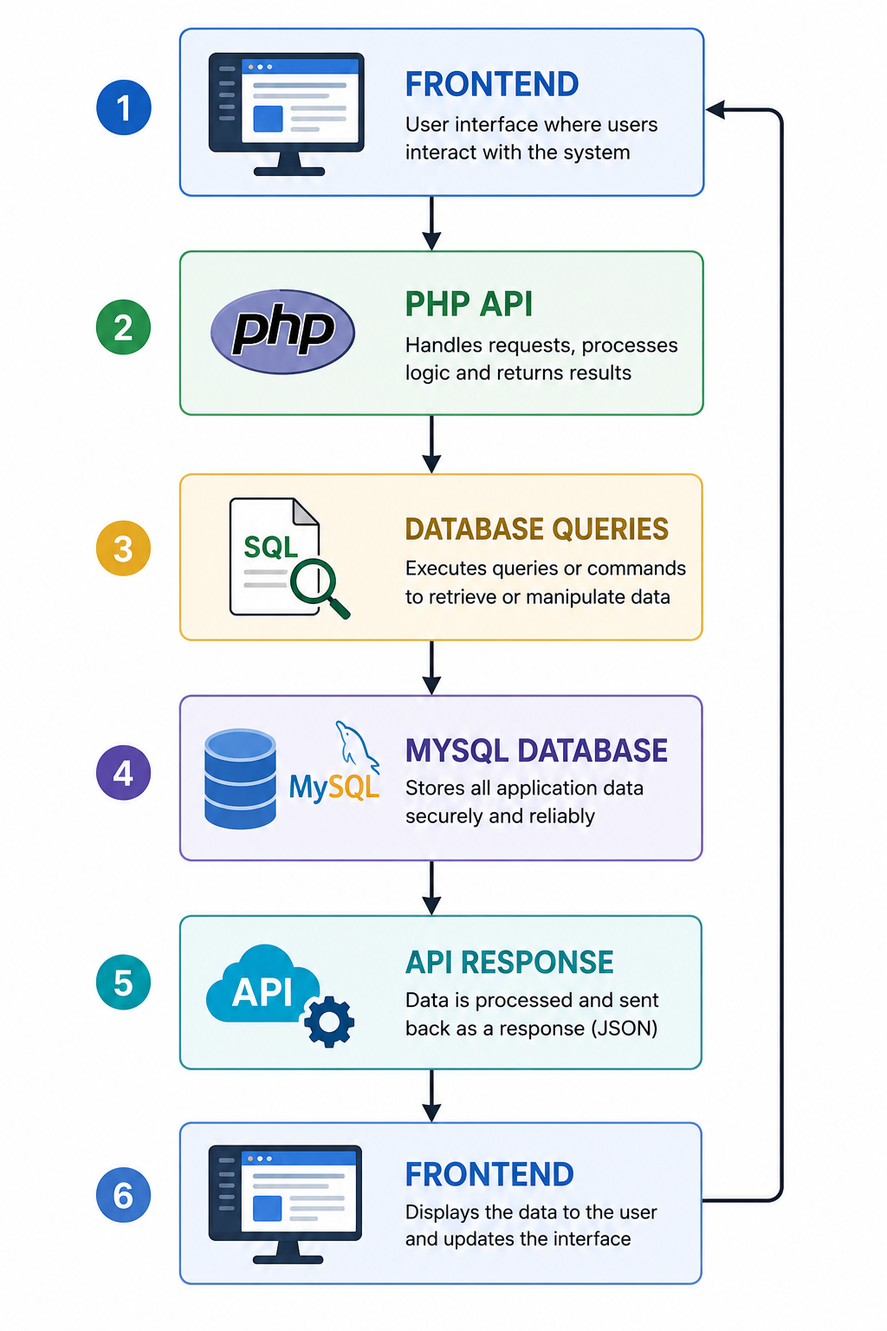
This approach provides an additional layer between the user interface and the database. It allows validation, authentication, authorisation, and application logic to be handled by the backend before database operations are performed.
The repository contains both docs/lms.sql and a compressed SQL database file, confirming that the database schema is maintained as part of the project.
8.4 Database Design Considerations
The database design supports the following requirements:
- Data consistency: Related information is maintained through database relationships.
- Data integrity: Database constraints and application validation help prevent invalid records.
- Reduced duplication: Related information is separated into appropriate entities.
- Scalability: Additional users, courses, and learning materials can be added without restructuring the entire system.
- Security: Database access is handled through the backend rather than exposing direct database access to users.
Overall, the relational database provides the data foundation for the GSLMS and supports the operation of the different modules through the PHP API.
9. API & BACKEND — SUMMARY
The GSLMS backend is a PHP RESTful API that connects the frontend to the MySQL database. It uses a structured architecture consisting of routing, authentication middleware, controllers, application services, and database operations.
The backend uses PHP 8+, Composer, JWT, PHP dotenv, PHPMailer, and PDO. Authentication is handled using JWT, with protected routes requiring user authentication before access is granted. The API supports major functions including user, student, teacher, course, role, permission, notification, chat, announcement, institution, and dashboard management.
The API uses standard HTTP methods such as GET, POST, PUT, and DELETE and returns data in JSON format. It also includes error handling and logging for authentication, access, auditing, debugging, email operations, and system errors.
Overall, the RESTful API provides a secure and organised communication layer between the frontend and database while keeping the system modular, maintainable, and extensible.
10. FRONTEND
The GSLMS frontend provides the user interface for administrators, teachers, students, and parents. It is separated from the PHP backend and communicates with it through a REST API rather than accessing the MySQL database directly.
The interface includes login, dashboards, student and teacher management, courses, learning materials, users and roles, notifications, announcements, chat, institutions, system settings, and profiles. The available functions and dashboards are presented according to the user's role.
The frontend uses JavaScript assets and environment configuration to manage application settings and API communication. The separation of the frontend and backend improves system maintainability, flexibility, and future scalability.
11. SECURITY — SUMMARY
The GSLMS implements security through JWT-based authentication, role-based authorisation, protected API endpoints, input validation, and environment-based configuration. Users must authenticate before accessing protected resources, while roles such as Super Administrator, Administrator, Teacher, Student, and Parent determine available functions.
The system also uses environment variables to protect sensitive configuration such as JWT credentials and provides logging and error-handling mechanisms for monitoring security-related activities and system errors.
12. CHALLENGES AND SOLUTIONS — SUMMARY
During the development of the GSLMS, challenges were encountered in frontend–backend integration, authentication, database management, API routing, server configuration, and error handling. These were addressed by separating the frontend and backend, implementing RESTful APIs and JWT authentication, using a structured MySQL database, introducing environment-based configuration, and maintaining system logs for troubleshooting.
The modular architecture also helped simplify the development and maintenance of the different system components.
13. CONCLUSION AND FUTURE IMPROVEMENTS
13.1 Conclusion
The Ghana Senior High School Learning Management System (GSLMS) has been successfully developed as a web-based platform for supporting digital teaching, learning, and academic management. The system integrates a JavaScript frontend, PHP REST API, MySQL database, authentication, role-based access, and server infrastructure into a single platform.
The completed system provides a structured environment for administrators, teachers, students, and other authorised users to manage and access learning-related services. The separation of the frontend and backend also provides a maintainable foundation for future development.
13.2 Future Improvements
Future versions of the system can be enhanced by introducing:
- A dedicated mobile application for students and teachers.
- Online examinations and quizzes with automatic grading.
- Advanced student performance analytics and reports.
- Email and SMS notifications for important academic activities.
- Integration with online payment services where required.
- Improved file storage and document management.
- Enhanced backup and disaster-recovery mechanisms.
- Integration with other school management and educational platforms.
- Additional security measures such as multi-factor authentication.
- Improved system performance and scalability for larger numbers of schools and users.
Overall, GSLMS provides a strong foundation for the digital management of learning activities in Ghanaian Senior High Schools and can be expanded as additional educational requirements emerge.
14. REFERENCES
The following technologies and frameworks were used in the development and implementation of the GSLMS:
- PHP Documentation — PHP programming language and server-side development.
- MySQL Documentation — Relational database management.
- JavaScript Documentation — Frontend development and API interaction.
- Nginx Documentation — Web server and reverse-proxy configuration.
- Composer Documentation — PHP dependency management.
- Firebase PHP-JWT — JSON Web Token authentication.
- PHP dotenv — Environment configuration management.
- PHPMailer — Email communication and notification services.
- GitHub — Source-code hosting and version control.

